SEG 2105

**Final Report**

**Fitness Class Booking Application**

**Submitted by:**

Group 23

Alexzander Gingras

Owen Stafford

Emirali Gungor

Oboro Onoruvwe

Tamer Verir

5th of December 2021

University of OttawaIntroduction

1. Introduction

Our team had been tasked to develop a basic fitness class booking service for a fitness center. Throughout the course of the 2021 Fall semester, we had periodically worked on this program, slowly implementing a thoroughly testing each new method and component.

Our application allows for three different types of users to interact within the environment: Admins, Instructors, and Members. **Admins** can create, delete, and edit class types. They also have the power to delete members of other types. **Instructors** can book, edit, and cancel classes that they host. They have access to a list of classes that they’ve booked and can see which members have enrolled to them. **Members** can browse the available courses and can filter by class type or class date. They can enroll into a class, or unenroll. They also have access to a list of courses they are currently enrolled in.

1. Final UML diagram

After incorporating the feedback received during deliverables 1 and 2, and further implementing the Member class, we finalized our UML diagram. We used UMPLE to aide us in its creation.

**NOTE:** Unfortunately, UMPLE doesn’t display the methods in the diagram, so I am including the code with the methods included in a separate file called “UML Methods.txt” and the original UMPLE file in “UMPLE Code.ump”.

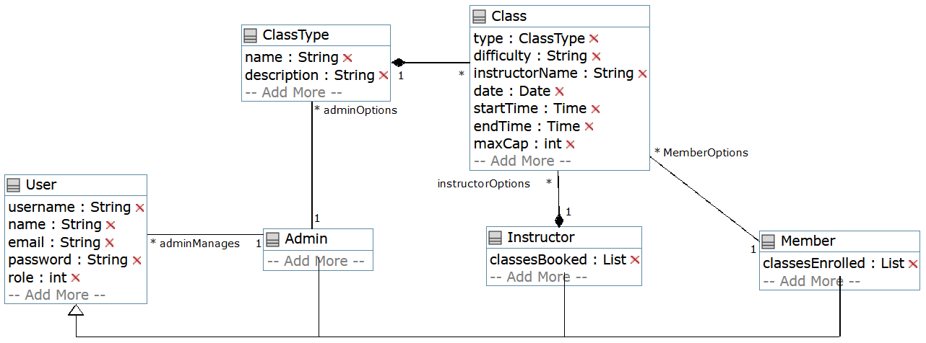

Figure 1: UMPLE generated UML diagram for app

1. Contribution table

|  |  |  |  |
| --- | --- | --- | --- |
| **Team Member** | **Deliverable 1** | **Deliverable 2** | **Deliverable 3** |
| Alexzander Gingras | Focused on the creation of the UML Diagram and tested the application | Updated the UML Diagram | Finalized the UML Diagram and created the final report |
| Owen Stafford | Focused on the creation of the application | Implemented the new features into the application | Finalized the application and peer reviewed the final report |
| Emirali Gungor | Committed name and student number to the git | Assisted in the development of the application |  |
| Oboro Onoruvwe | Committed name and student number to the git |  |  |
| Tamer Verir | Committed name and student number to the git |  |  |

1. App screenshots
2. Lessons/Challenges

Throughout the course of our project, we encountered many challenges. Our biggest challenge being the fact that it was primarily 3/5 team members working on both the deliverables and the labs. This forced us to strategize and split the tasks between the individuals who felt most comfortable doing them. Despite our efforts, we still fell short as we also had other courses with assignments and midterms to focus on, as well as personal jobs.

After deliverable 1, Alexzander was unable to assist in the development the application as he kept getting errors regarding Gradle and was unable to resolve it. He continued to support the team and kept everyone up to date with the submission deadlines, as well as focus on completing tasks that didn’t require Android Studio.

Disregarding the difficulties that we were presented with, this project proved to be a valuable experience. It taught us how to efficiently manage our time and familiarized us with the development of android applications. This was also the first time any of us had used SQLite, which ended up being very useful. We look forward to potentially working together in the future again.